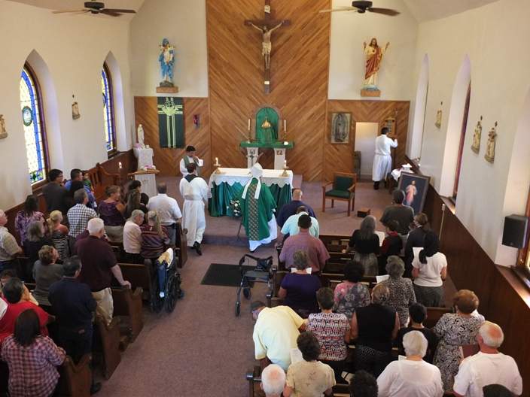
Entrance

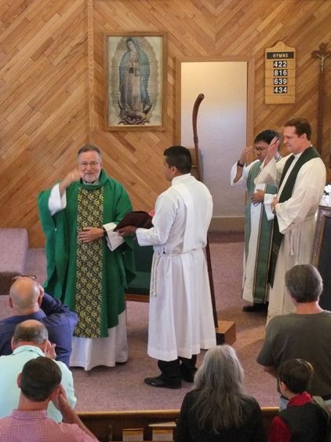
Sign of the Cross
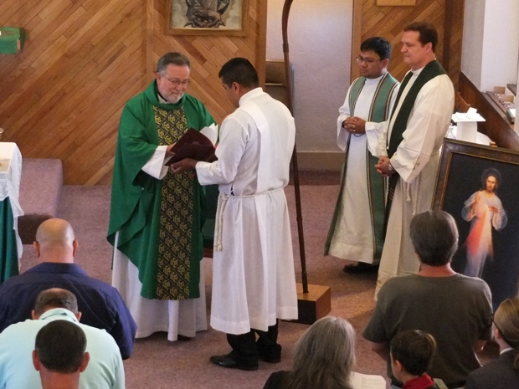
Opening Prayer

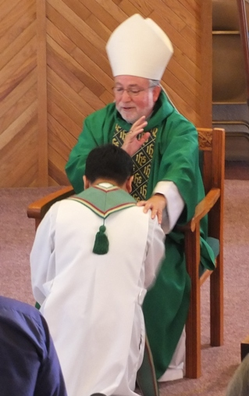
Bishop Soto Blesses Fr. Jhay before reading the Gospel
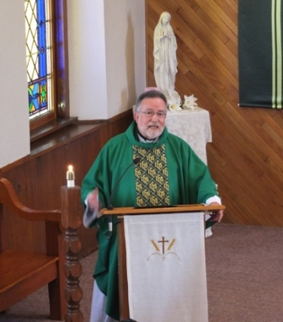
Bishop Soto Presents the Homily on Mercy

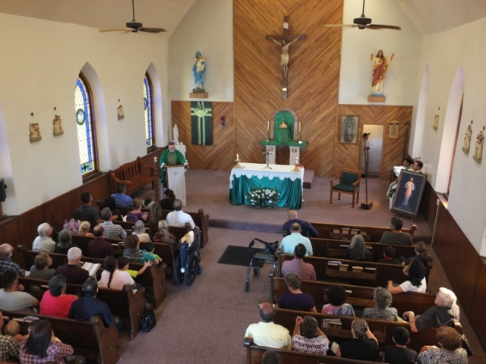
Assembly of the Faithful listen to the Homily
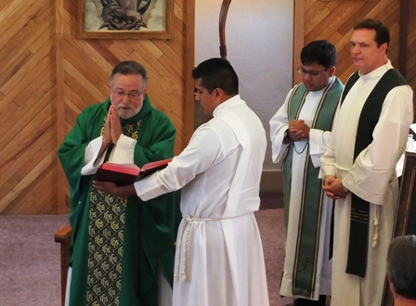
Credo

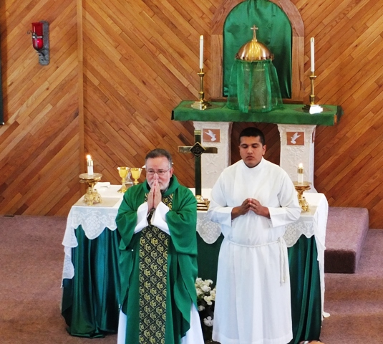
Bishop Soto waits for the Presentation of the Gifts with seminarian Alex
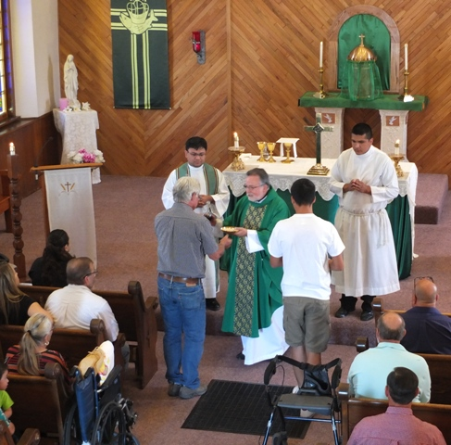
Bishop Soto Receives the Gifts from Joe Catania and another presenter.

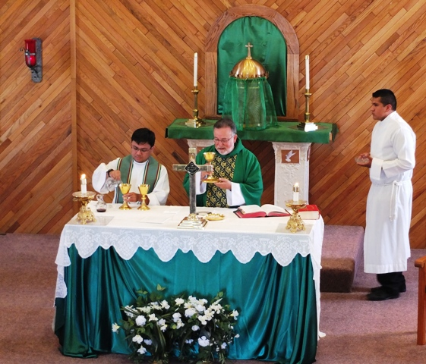
Preparation of the Gifts by Fr. Jhay and Bishop Soto
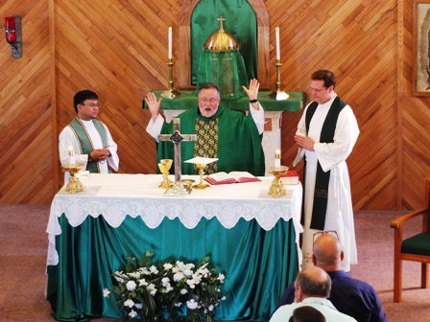
Bishop Soto— flanked by Fr. Jhay & Fr. Mark—Delivers the Eucharistic Prayer

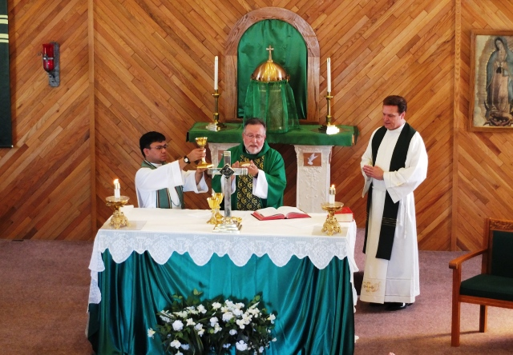
“Through Him, with Him and in Him…” Doxology of Eucharistic Prayer
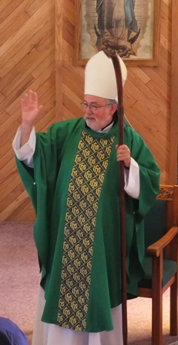
Bishop Soto gives the Final Blessing

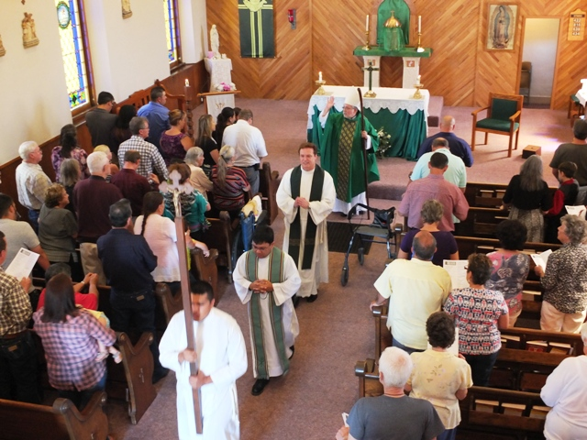
Bishop Soto Blesses the Congregation during the Recessional.
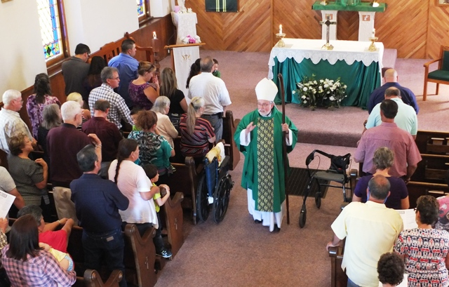
Recessional
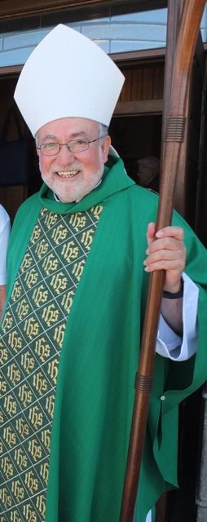
Bishop Soto Meets and Greets Parishioners after Mass.
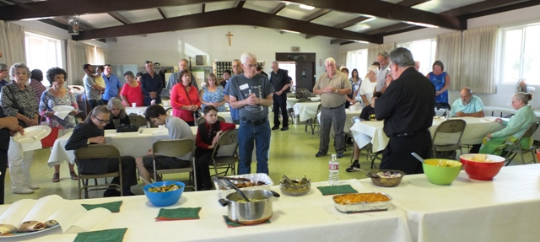
Potluck Luncheon Following Mass

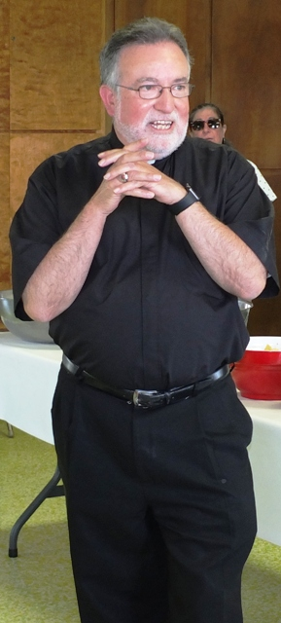
Bishop Soto Offers a Blessing before We eat.
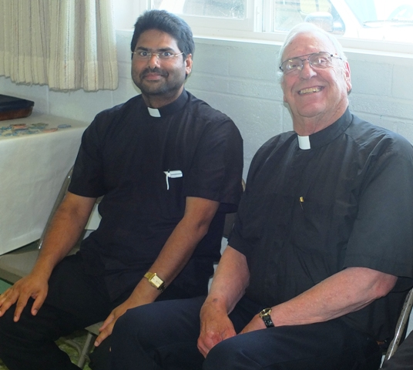
Our Dear Friends from Lakeview:
Fr. Thomas Philip (new pastor) and Fr. Ray Hopp (retired pastor) of St. Patrick Church

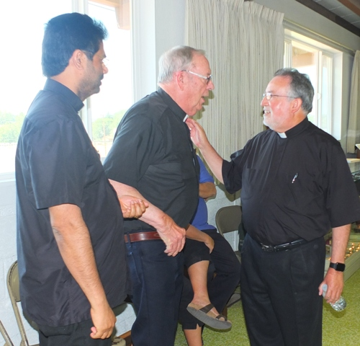
Bishop Soto Greets Fr. Thomas and Fr. Ray
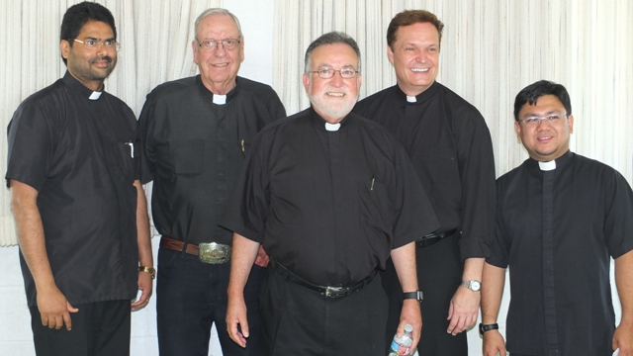
L to R: Fr. Thomas, Fr. Ray, Bishop Soto, Fr. Mark, Fr. Jhay

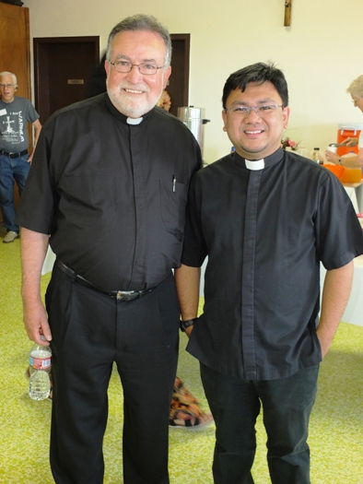
Bishop Jaime Soto, Bishop of the Diocese of Sacramento &
Fr Jhay Galeon, Pastor of Sacred Heart Church in Alturas
Sacred Heart Parish Hall
August 14, 2016

