**Fr. Bernardin Mugabo’s Farewell Potluck - June 21, 2015  
*Photos by George Studinski***

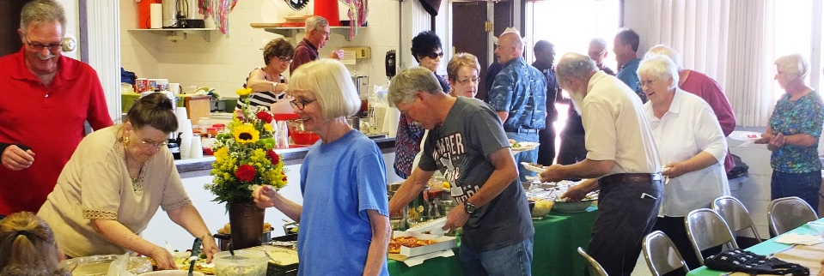

Randy Christensen, Pat Wood, Carla & Don Mason, Johnalynn & Ray O’Malley, Pauline Westman

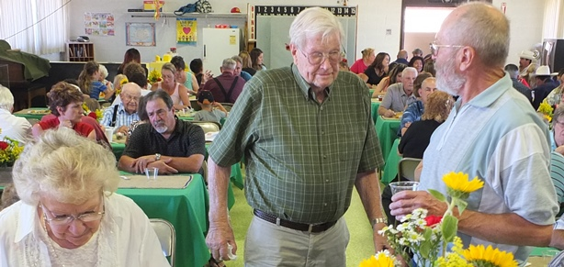

Cordelia Rosendahl, Gus Dekker, Bob Hassenmiller

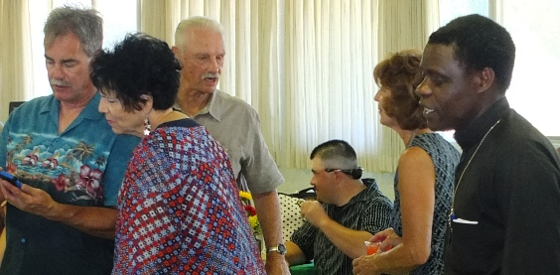

Jake Gysin, Johnalynn O’Malley, Elwood & Maria Cantrall, Fr. Bernardin

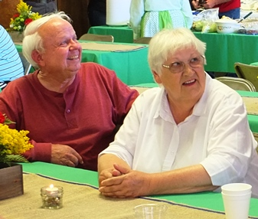 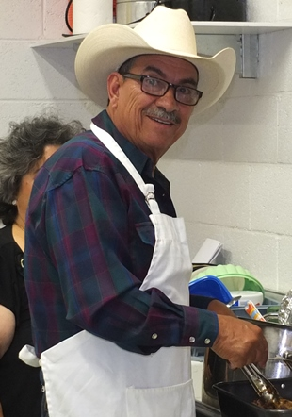

Isidro Chavez

Richard & Pauline Westman

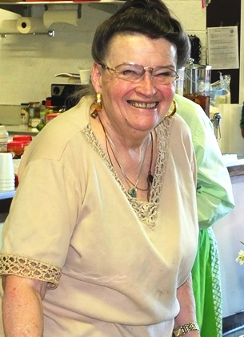 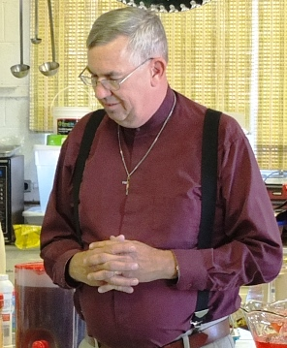

Rev. Ben Zandstra

Pat Wood

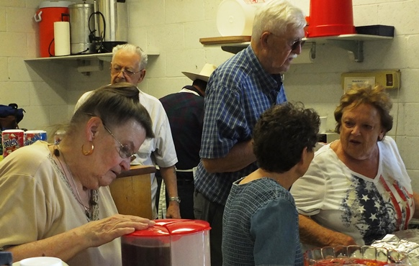

Pat Wood, Art Abasta, Marty & Suzy Young, Carol Irwin

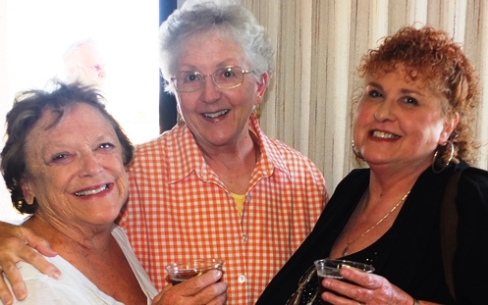

Suzy Young, Yvonne Studinski, Kathy Hassenmiller

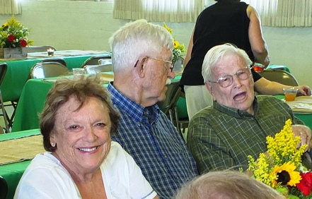

Suzy & Marty Young, Gus Dekker

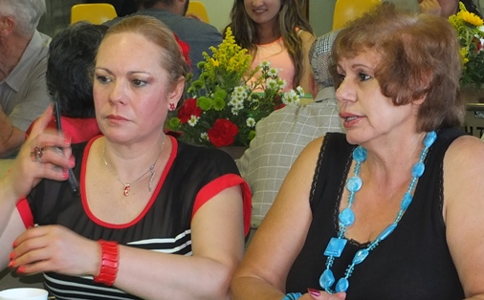

Rosario, Concepcion Quezada

Gus Dekker, Marty Young

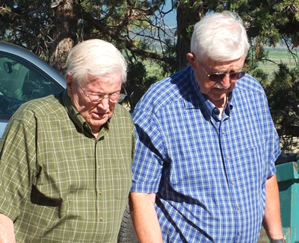 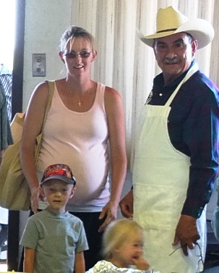

Kristen & Tanner Daly   
& (Hannah in Mama’s tummy)  
Isidro Chavez

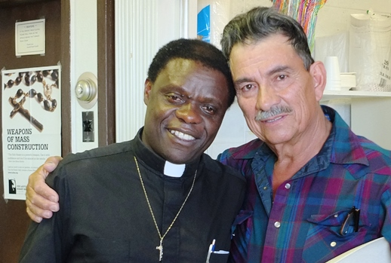

Fr. B. & Isidro Chavez

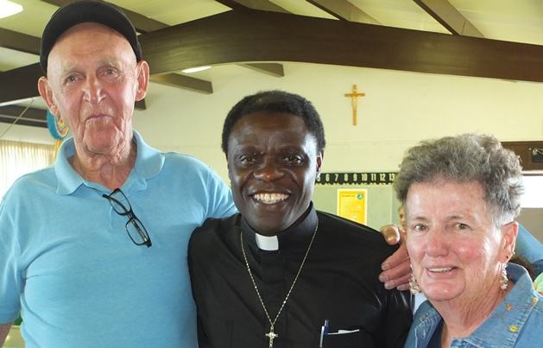

Max & Kay Helton & Fr. B.

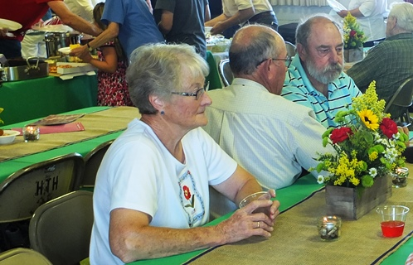

Rose & Dave Jacquot, Dennis Banister

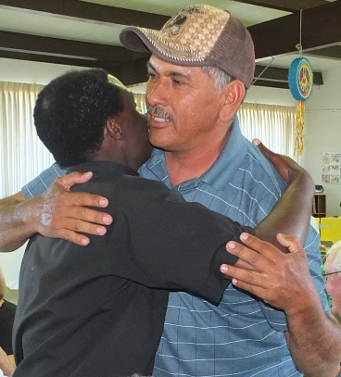 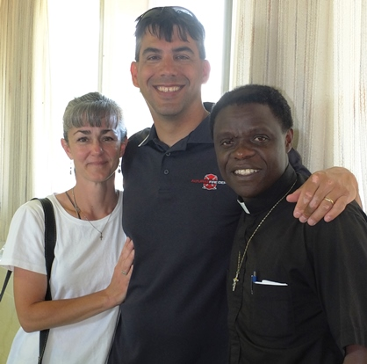

Julie & Tom O’Malley, Fr. B.

Kwaheri, Rafiki yangu!

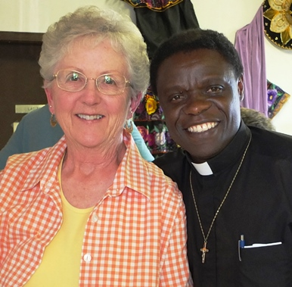

Yvonne Studinski & Fr. B.