***George Studinski, Photographer***

Father Michael Kiernan was Pastor of Sacred Heart Church and St. James Mission from 1977 to 1981. He was responsible for the renovation of the church. Father Michael returned to visit Modoc after a very long absence. We are grateful for the time he spent with us while we were transitioning between Fr. Jhay Galeon and Fr. Arlon Vergara.

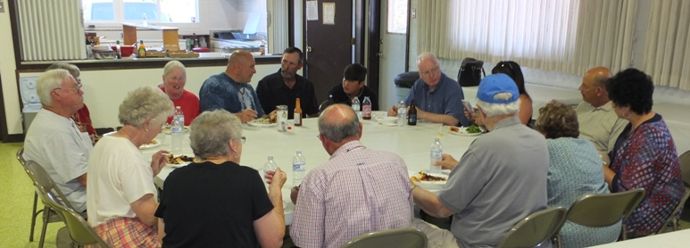

From the left, clockwise: David & Wanda (hidden) Rhoades, Sally Olsen, Frankie Torrano, Fernand &Tre Larranaga,  
 Fr. Michael, Victoria Larranaga (hidden), Ray & Johnalynn O’Malley, Suzy & Marty Young, Dave & Rose Jacquot, Yvonne Studinski

Fr. Michael with Johnalynn & Ray O’Malley

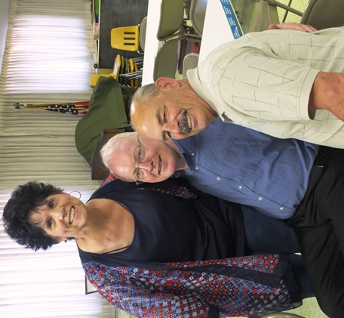

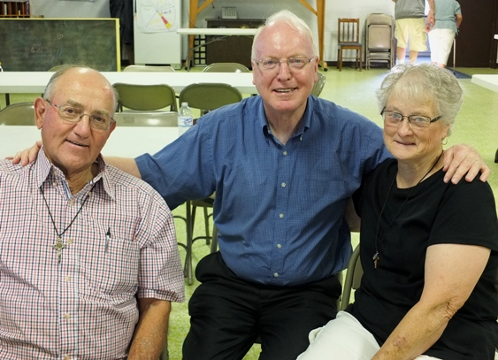

Fr. Michael with Dave & Rose Jacquot

F

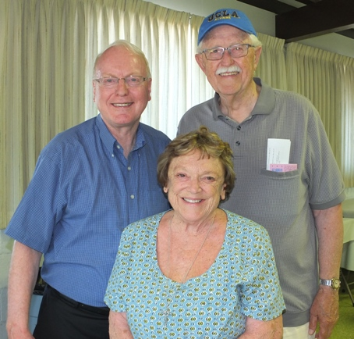  
Fr. Michael with Marty & Suzy Young

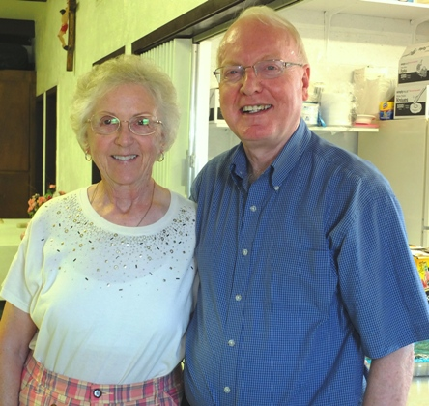

Fr. Michael with Yvonne Studinski (herself)

**Sacred Heart Parish Hall  
June 24, 2017**