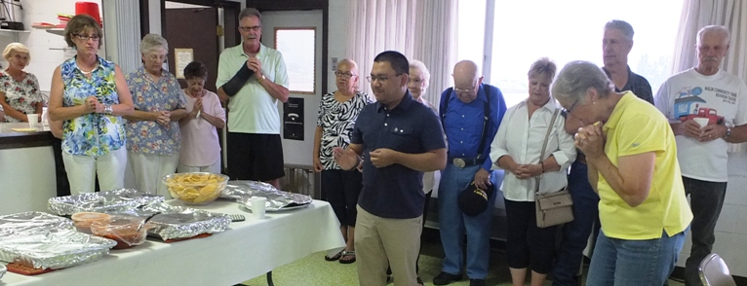

Kathy, Yvonne, Carol, Randy, Fr. Jhay, Cordelia, Harold, Audry, Rose Mike, Elwood

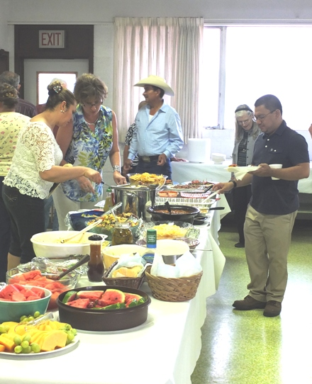

Rosario, Kathy, Isidro, Fr. Jhay

**Sacred Heart Parish Hall  
August 2, 2015**

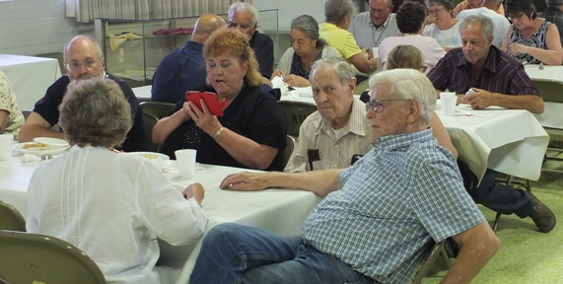

Bob, Kathy, Virgil, Gus; (back row) Frankie, Carlos, Maria, Tony

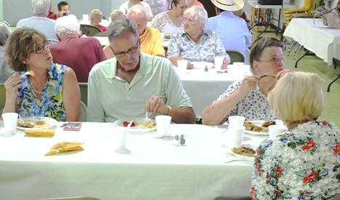

Kathy, Randy, Pat; (back row)Richard, Pauline,