**Celebration of Fr. Stephen’s 21st Anniversary of his Ordination**

**September 13, 2021**

Father Stephen was ordained on September 13, 2000, in Colombo Srilanka. He belongs to the religious congregation of Oblates of Mary Immaculate

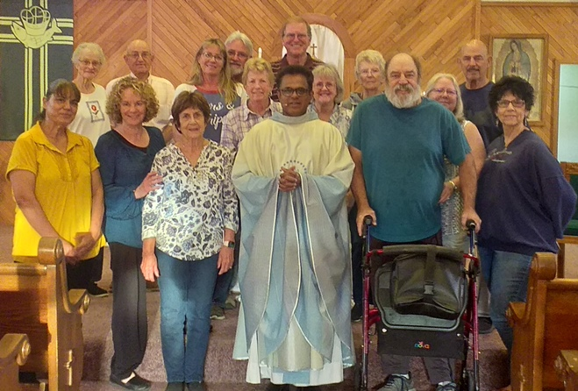

Parishioners who celebrated with Fr. Stephen included:

Rose & Dave Jaquot, Lori & Joe Catania, Tom Parnow, Janice Flynn, Ray O’Malley, Teresa Loza de Zuniga, Adele Mitchell, Jolene Caldwell, Penny Kenney, Wanda Rhoades, Dennis & Pam Banister, Johnalynn O’Malley. Also present , but not pictured, were Lisa Parnow, Julie O’Malley, & Yvonne Studinski.