Welcome Potluck for Fr. Arlon Vergara, OSA
July 9, 2017
(Photos by George Studinski)
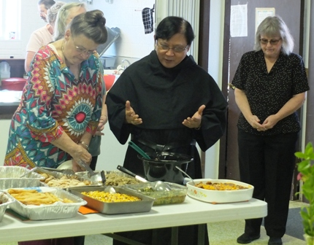
Fr. Arlon offers the blessing
while Pat Wood (L) and Wanda Rhoades stand by.
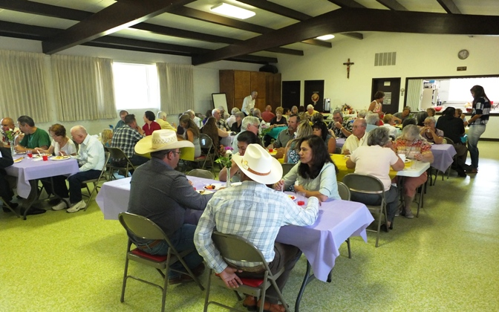
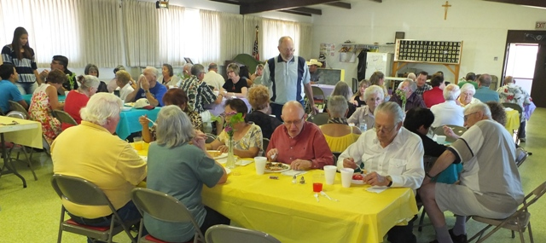
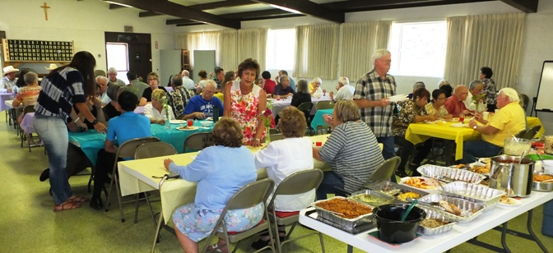
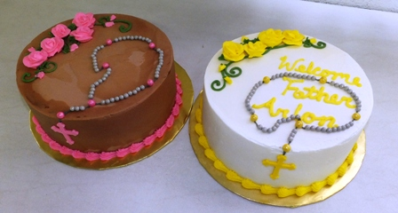
Beautiful (and tasty!) cakes
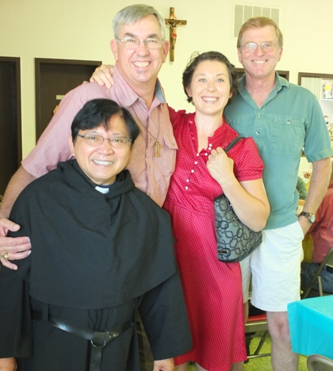
Rev. Ben Zandstra, Rachel Gauna and Tom Parnow with Fr. Arlon
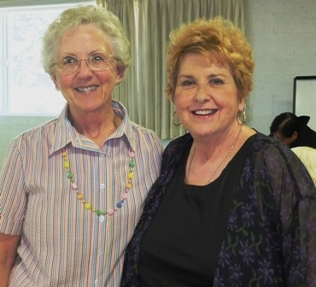
Yvonne Studinski and Kathy Hassenmiller
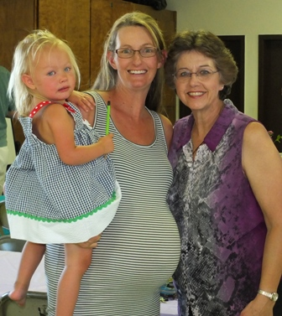
Hannah Daly and Mom Kristen and ???? in her tummy (due early August)
with Lisa Parnow (surrogate grandma)

