Pastor of Sacred Heart Parish — Fr. Arlon Vergara, OSA
July 9, 2017
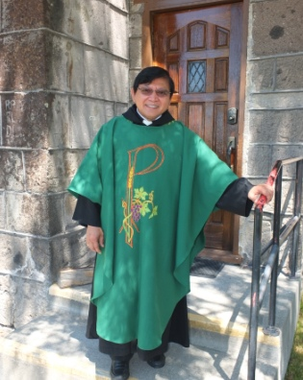 | 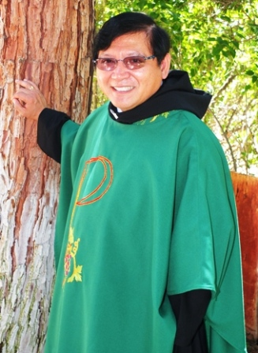
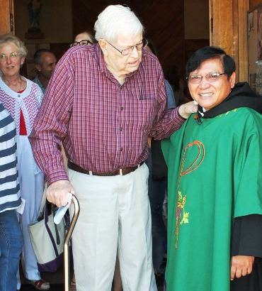 | 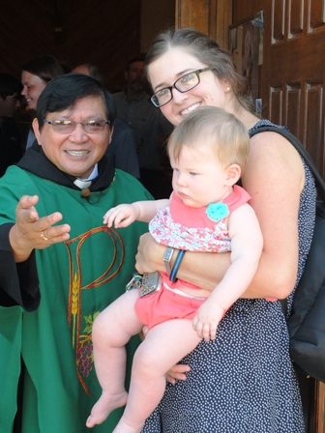
Gus Dekker & Father | Father with Stacy Todd  & baby Evelyn

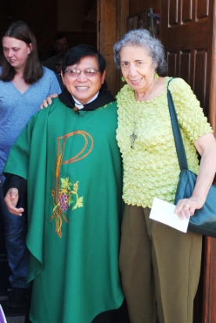 | 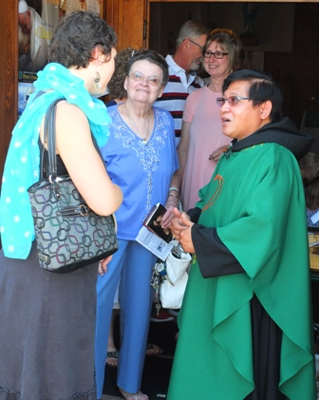
Father & Maria Rodrigues | Rachel Gauna, Pat Wood, and  Randy & Cathy Christensen (back)  with Father
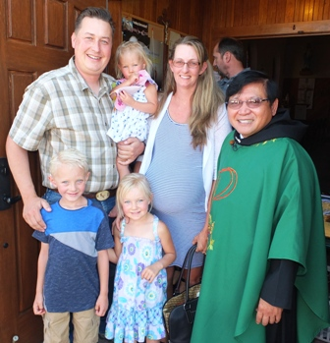 | 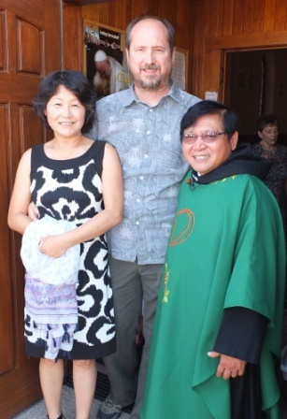
John & Kristen Daly & family  with Father | Father with friends  from another parish

